## Execution steps

### Run the Simulator and AWK script

First, Run the simulator

```

ns lab5.tcl

```

### Compile and run the awk script

```

awk -f lab5.awk lab5.tr file1.tr>tcp0

awk -f lab5.awk lab5.tr file2.tr>tcp2

```

### create a xgraph

```

xgraph -x "time" -y "convalue" tcp0 tcp2

```

##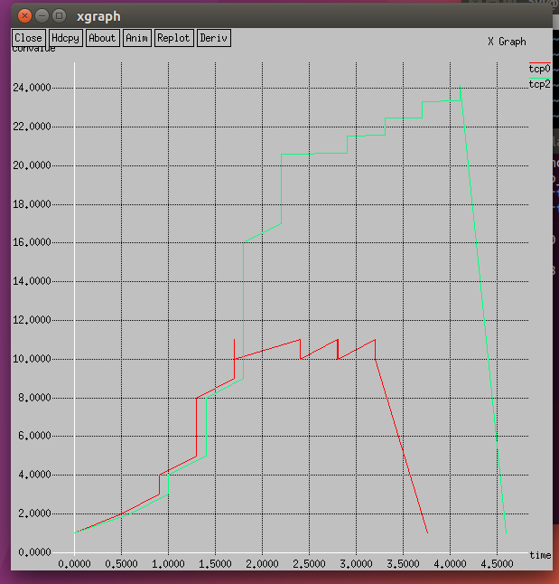# Screenshot

![Alt text](xgraph1.png?raw=true "xgraph")